Logistic Regression and Naive Bayes with Auto Dataset

Michael Kamp

October 02, 2025

## Introduction

In this assignment, I will use the Auto data set to compare two classification methods: Logistic Regression and Naive Bayes. I will predict whether a car’s mpg is above the median (mpg01) using selected predictors, and evaluate performance using confusion matrices and accuracy.

# Load libraries quietly  
library(ISLR2)  
library(e1071)  
library(caret)  
library(ggplot2)  
  
# Load Auto data set  
data(Auto)  
  
# Create binary response mpg01  
Auto$mpg01 <- ifelse(Auto$mpg > median(Auto$mpg), 1, 0)  
  
# Create training and test sets (Week 1 split)  
set.seed(1)  
train <- sample(1:nrow(Auto), nrow(Auto)/2)  
test <- -train  
  
Auto_train <- Auto[train, ]  
Auto_test <- Auto[test, ]

## Question 1: Logistic Regression vs Naive Bayes

# Logistic Regression  
glm_fit <- glm(mpg01 ~ cylinders + horsepower + weight,   
 data = Auto_train, family = binomial)  
  
glm_probs <- predict(glm_fit, Auto_test, type = "response")  
glm_pred <- ifelse(glm_probs > 0.5, 1, 0)  
  
# Confusion matrix & accuracy  
confusionMatrix(as.factor(glm_pred), as.factor(Auto_test$mpg01))$table

## Reference  
## Prediction 0 1  
## 0 90 9  
## 1 12 85

# Accuracy  
glm_acc <- mean(glm_pred == Auto_test$mpg01)  
glm_acc

## [1] 0.8928571

# Naive Bayes  
nb_fit_q1 <- naiveBayes(mpg01 ~ cylinders + horsepower + weight, data = Auto_train)  
  
nb_pred_q1 <- predict(nb_fit_q1, Auto_test)  
  
# Cleaner confusion matrix  
confusionMatrix(as.factor(nb_pred_q1), as.factor(Auto_test$mpg01))$table

## Reference  
## Prediction 0 1  
## 0 88 9  
## 1 14 85

# Accuracy  
nb_acc <- mean(nb_pred_q1 == Auto_test$mpg01)  
nb_acc

## [1] 0.8826531

# Accuracy Comparison  
results_q1 <- data.frame(  
 Model = c("Logistic Regression", "Naive Bayes"),  
 Accuracy = c(glm_acc, nb_acc)  
)  
  
# Show results as table  
results_q1

## Model Accuracy  
## 1 Logistic Regression 0.8928571  
## 2 Naive Bayes 0.8826531

# Bar chart for visual comparison  
ggplot(results_q1, aes(x = Model, y = Accuracy, fill = Model)) +  
 geom_col(width = 0.6) +  
 geom_text(aes(label = round(Accuracy, 3)), vjust = -0.5, size = 5) +  
 labs(title = "Model Accuracy Comparison", y = "Accuracy", x = "Model") +  
 ylim(0, 1) +  
 theme_minimal() +  
 theme(legend.position = "none")

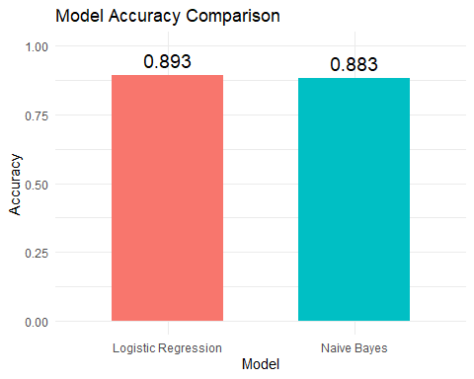

## Conclusion

Logistic Regression achieved an accuracy of about 89.29%,  
while Naive Bayes achieved an accuracy of about 88.27%.

Both models performed similarly, with Logistic Regression slightly higher.  
This suggests either method provides strong performance for predicting whether a car’s mpg is above or below the median.

## Question 14(g): Naive Bayes with Auto Dataset

# Fit Naive Bayes model  
nb_fit <- naiveBayes(mpg01 ~ cylinders + horsepower + weight, data = Auto_train)  
  
# Predict on test data  
nb_pred <- predict(nb_fit, Auto_test)  
  
# Confusion matrix  
confusionMatrix(as.factor(nb_pred), as.factor(Auto_test$mpg01))$table

## Reference  
## Prediction 0 1  
## 0 88 9  
## 1 14 85

# Test error  
nb_test_error <- mean(nb_pred != Auto_test$mpg01)  
nb_test_error

## [1] 0.1173469

## Conclusion

In Problem 14(g), I applied a Naive Bayes classifier to the Auto data set using the training/test split defined earlier. The predictors selected (cylinders, horsepower, and weight) were those most associated with mpg01 from part (b).

The model’s predictions on the test set produced the confusion matrix shown above. The overall test error rate was approximately 11.73%, meaning the model misclassified about that percentage of the test observations.

This indicates that the Naive Bayes approach performs reasonably well in distinguishing cars with above-median mpg from those with below-median mpg.

### Final Takeaway

Overall, both Logistic Regression and Naive Bayes provided strong predictive performance on the Auto data set, with Logistic Regression showing slightly higher accuracy and Naive Bayes demonstrating a low test error rate. These results suggest that either approach is effective for classifying cars by above- or below-median mpg.